EXP-2 Bias Audit on Word Embeddings using WEAT

AIM:
To perform a Bias Audit on pre-trained word embeddings to identify gender or racial stereotypes using the Word Embedding Association Test (WEAT).

DATASET:
Pre-trained Word Embeddings (Google News Word2Vec / Common Crawl GloVe)

PROCEDURE:

Step 1: Install and Import Libraries !pip install gensim numpy scipy import numpy as np from scipy.spatial.distance import cosine import gensim.downloader as api

Step 2: Load Pre-trained Word Embeddings
Load Google News Word2Vec embeddings (large model) model = api.load("word2vec-google-news-300")

Step 3: Define Target and Attribute Word Sets Target words male_words = ["man", "boy", "father", "he", "son"] female_words = ["woman", "girl", "mother", "she", "daughter"] Attribute words
career_words = ["career", "corporation", "salary", "office", "professional"] family_words = ["home", "family",
"children", "kitchen", "marriage"]

Step 4: Define Cosine Similarity Function
def cosine_similarity(w1, w2):
return 1 - cosine(model[w1], model[w2])

AD23633 231501020

Step 5: Association Function (WEAT Core) def association(w, A, B):  return np.mean([cosine_similarity(w, a) for a in A]) - \ np.mean([cosine_similarity(w, b) for b in B])  Step 6: Compute WEAT Test Statistic  def weat_statistic(X, Y, A, B):  return sum(association(x, A, B) for x in X) - sum(association(y, A, B) for y in Y) weat_score = weat_statistic(male_words, female_words, career_words, family_words) weat_score  Step 7: Effect Size Calculation def effect_size(X, Y, A, B):  assoc_X = [association(x, A, B) for x in X] assoc_Y = [association(y, A, B) for y in Y]  mean_diff = np.mean(assoc_X) - np.mean(assoc_Y)  std_dev = np.std(assoc_X + assoc_Y) return mean_diff / std_dev  effect = effect_size(male_words, female_words, career_words, family_words)  effect  Step 8: Permutation Test (Statistical Significance) import random def permutation_test(X, Y, A, B, iterations=1000):  combined = X + Y observed = weat_statistic(X, Y, A, B) count = 0 for _ in range(iterations):  random.shuffle(combined) X_perm = combined[:len(X)] Y_perm =  AD23633 |  | 231501020
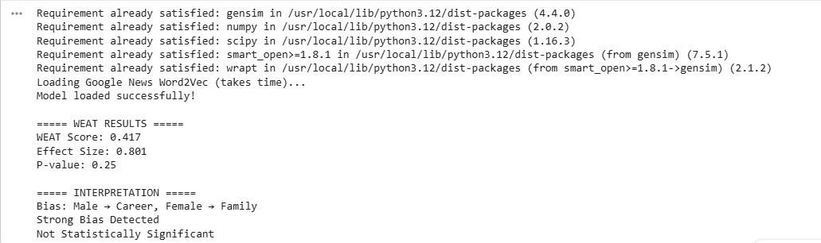
AD23633

231501020

combined[len(X):]

perm_stat

=

weat_statistic(X_perm,

Y_perm,

A,

B) if
abs(perm_stat) > abs(observed):

count

+=

1

return

count

/

iterations

p_value

=

permutation_test(male_words,

female_words,

career_words,

family_words)
p_value

Output:

RESULT:

Bias

exists

in

pre
-
trained

word

embeddings,

demonstrating

that

models

trained

on

large

text

corpora

inherit

human
-
like

stereotypes
,

which

must

be

mitigated

in

AI

systems.

